

Artificial Intelligence and Data Engineering

Distributed Systems and Middleware Technologies

Project Documentation

FASTDOKU

Students:

Rossella De Domenicis

Armando Macrì

Academic Year: 2021-2021

Summary

Introduction 2

Design 3

Functional and Non-Functional Requirements 3

Main Actor 3

Functional Requirements 4

Non-Functional requirements 4

Use case 4

Data model 6

Architecture 7

Client side 8

Technologies 9

Server side 10

Technologies 10

WebSocket 10

Synchronization 12

Communication 14

Coordination 15

User Manual 17

# Introduction

Sudoku is a very popular game whose rules are very simple but which can be tricky to solve in some cases. It is a logic game in which the player is offered a grid of 9 × 9 cells (or more), each of which can contain a number from 1 to 9, or be empty; the grid is divided into 9 horizontal rows, 9 vertical columns and 9 "sub-grids" of 3 × 3 contiguous cells.



**FASTDOKU** is a web application very simple and intuitive that allows friends or random strangers to challenge each other with sudoku puzzles. A match consists of completing the sudoku puzzle in as little time as possible. When a player believes that he has completed the puzzle correctly, he asks the system through a special button to "check the solution"; if it is correct, the player wins and the game is interrupted even for the loser, but during a game it is possible to surrender automatically giving victory to the opponent.

**FASTDOKU** is a composition of two words: ***faster*** and ***sudoku***. This is to emphasize that that the faster player wins the match and earns points.

The size of the grid is fixed: 9x9. To start a match with another player you need to send a request to the other user and decide on a difficulty level: "very easy", "easy", "normal", "hard", "expert". The level is set for that specific game, so you can increase or decrease as needed with each new game. The puzzle, during a match, is randomly assigned and the two players will not have the same puzzle, only the same level of difficulty.

# Design

## Functional and Non-Functional Requirements

This section describes the requirements that the application must provide.

### Main Actor

The application interacts only with one entity, the user.

* A ***user*** interacts with the application and make use of all the functionalities provided.

### Functional Requirements

An unregister user can only ***sign up*** in order to become a registered user.

A user is allowed to:

* ***Sign in*** in the application
* ***Logout*** from the application
* ***Delete*** his own profile
* ***Visualize*** his own score
* ***Browse*** all the online user
* ***Send*** a request to a user
* ***Select*** game difficulty
* ***Accept/refuse*** a request
* ***Visualize*** ranking
* ***Play*** the game
* ***Surrender***

### Non-Functional requirements

* The application must be simple, intuitive and offer an experience enjoyable for the user.
* The password must be protected and stored in an encrypted form.
* The code must be readable and easy to maintain.
* It is necessary to develop at least one application part in Erlang.
* Synchronization, communication and coordination must be handle.

# Use case

In this application there is just one main actor.

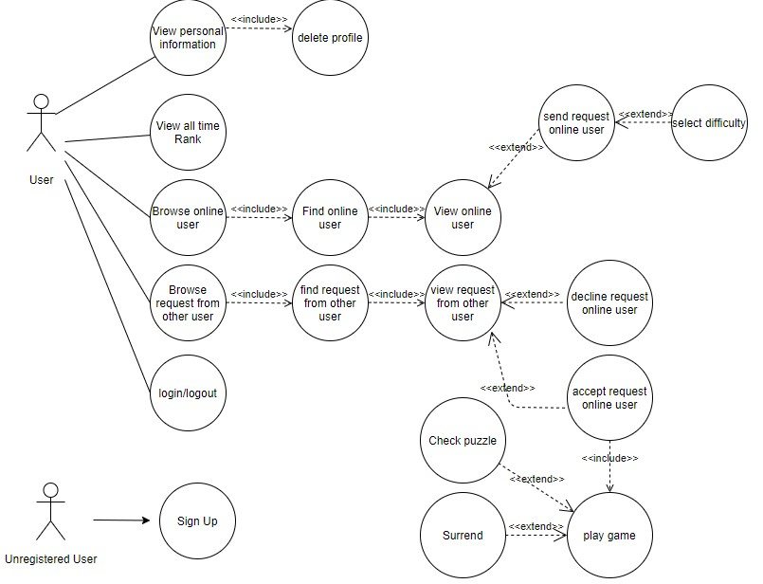

An unregistered user can:

* **Sign Up**: the first time a user uses the application he/she will be asked to register himself/herself, providing a- username and a password.

A registered user can:

* **Login/Logout**: a user can login in the application using its credentials (username, password). When logged in, he can logout from the application at any time.
* **View personal information**: when user log in, his/her personal information are shown, including his/her score and username.
* **Delete**: a user can delete his/her profile.
* **View Rank**: a user can view the ranking of users have earned the most points.
* **Brows-find-view** **user**: the application shows the list of all the online users.
* **Brows-find-view request**: the application show the list of all the requests arrived.
* **Send request**: a user can send a request to another online user available to play.
* **Select difficulty**: before sending a request, the user must select the difficulty of the game.
* **Accept/Decline request**: a user can accept or decline a request received.
* **Play game**: when a user accepts a request automatically the game starts.
* **Check/Surrender**: when the game is started a user can surrender or check the puzzle; if the puzzle is correct, the game is over.

# Data model

The application doesn’t require a complex data structure because it has to handle only user information that is *username*, *password* and *points*. Moreover, the operation performed on the data are easy and not computationally heavy. These are the reason why we have decided to adopt a key-value database that guarantees faster response.

Key-value databases are the simplest of the NoSQL databases. The design of this type of data store is based on storing data with identifiers known as keys.

We choose LevelDB because offers the fast performance benefits of caches plus the persistent storage of databases; In this case it was preferred over other db because ease of storage and retrieval are more important than organizing data into more complex data structures, such as tables.

Keys are used to identify, index, or otherwise reference a value in a key-value database. The one essential property of a key is that it must be unique within a namespace.

The key-value database is organized in this way: the key is composed by the word ‘user’, the username and the attribute. Is an embed key with the

* entity name that is “user”;
* the entity identifier that is the “username”, unique for every user;
* the entity attribute that contains users' information such as points or password.

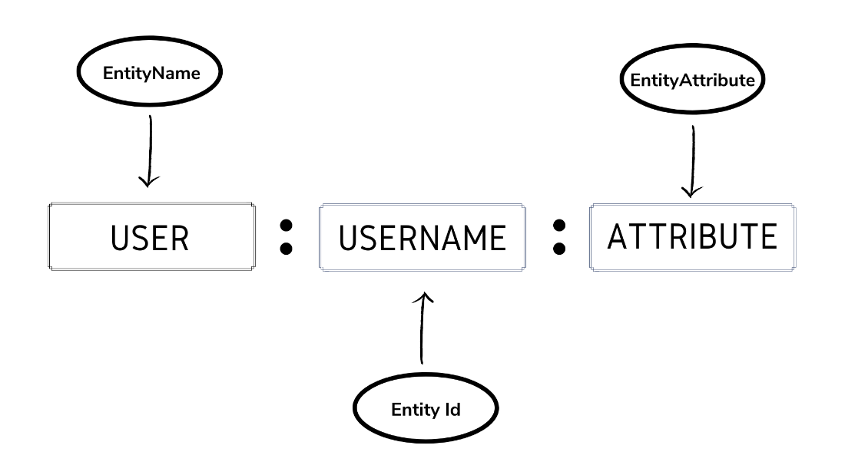

An example of a record in the database is “user : pippo : points: 2000”.

# Architecture

The application is organized as **a *client-server* application**: users through their web-browsers (the clients) can interact with the application that communicating with the web server.

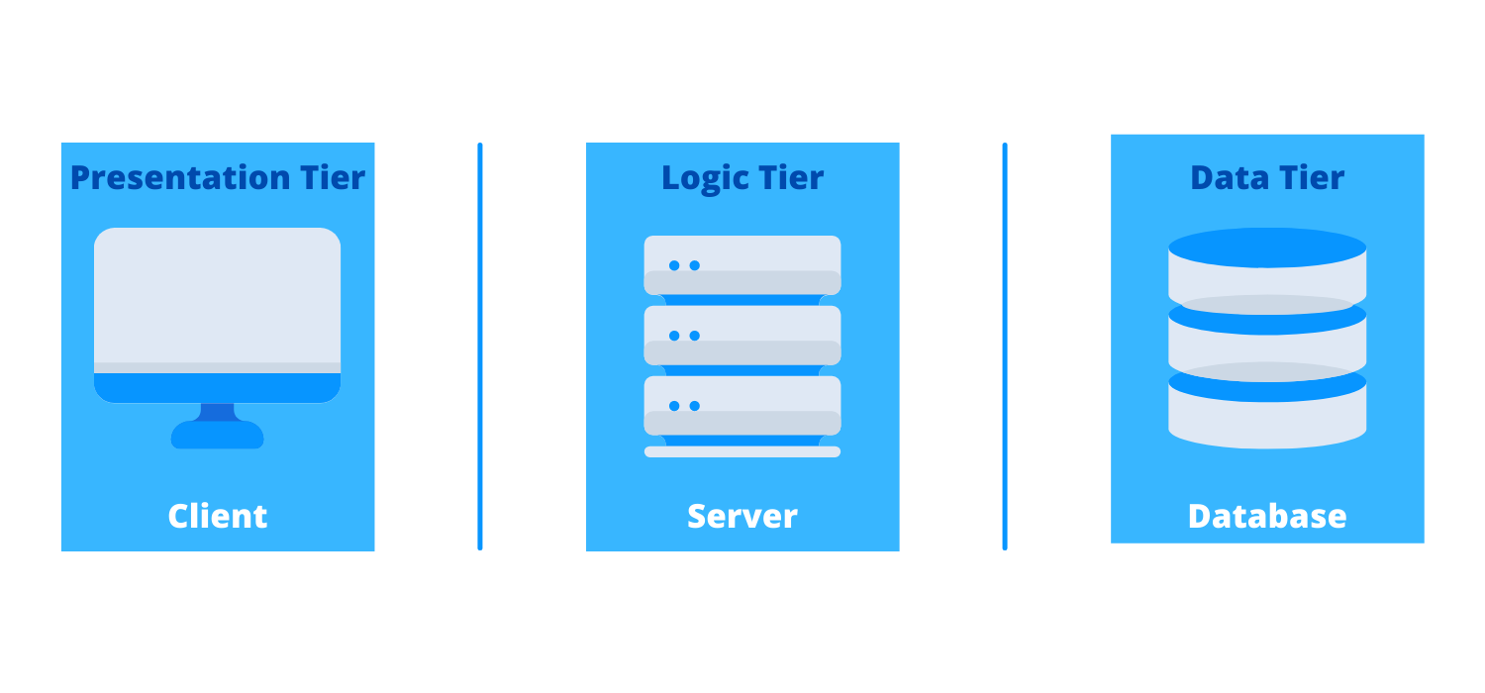

The application is structured into the typical web three-tier structure:

* The *presentation tier* corresponds to the front-end layer and it is involved in managing the user interface. It is built with HTML5, cascading style sheets (CSS), and JavaScript, and it is deployed through a web client that is Tomcat.
* The *logic tier* contains all the functional business logic that supports the application’s core functions. It consists of two parts, one written in Java and hosted on a Tomcat web server, and the other written in Erlang and hosted on a Cowboy server.
* The *data tier* consists of a Key-Value Database and a Database Management System (LevelDB by Google). This gives us high data flexibility, thanks to the ability to easily add/remove new entity attributes, and excellent speed performance.

All these parts are developed and maintained by independent modules. So it is possible to develop them in different platforms. This division of roles promotes simplicity as it is easier to maintain the code.

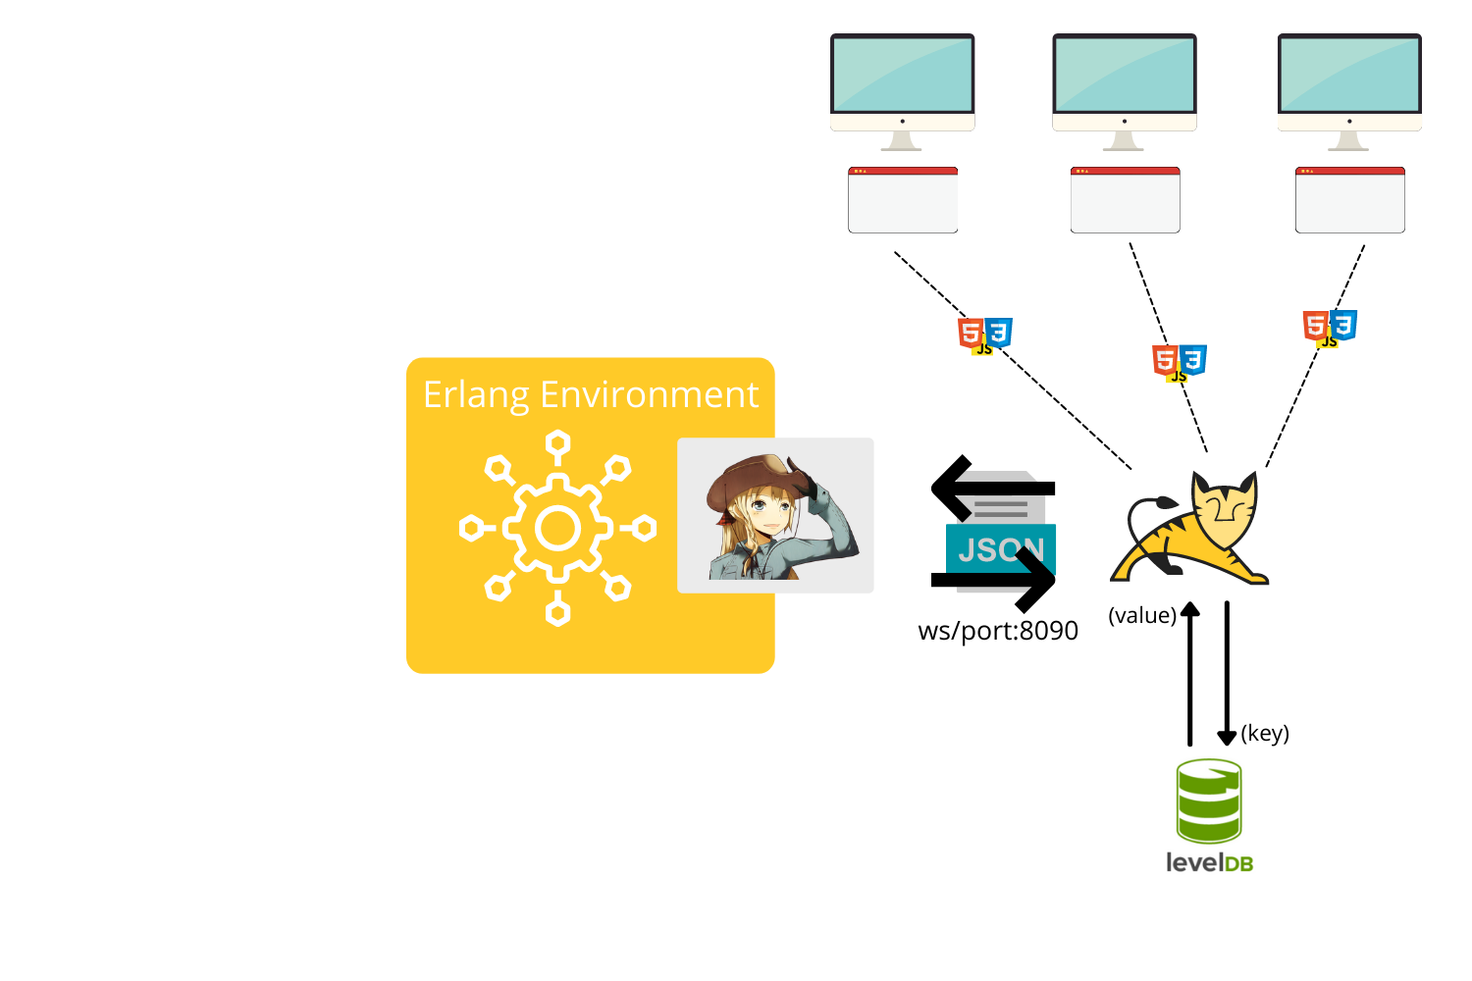

## Client side

The web client allows users to interact with the application. The web interface provides an intuitive and easy to use graphical interface where the user can visualize online users, accept requests, view ranking and so on.

The web application is deployed on a Tomcat server that provide response for user requests.

The software design pattern used is the **MVC** (Model-View-Controller) **pattern**. Each request from the web client is handled by the Controller. In our case, the Controller is a Filter/Servlet pair.

The Filters have been used to intercept and process requests before they are sent to servlets. They are in charge of carrying out checks, for example on input validation, data encryption or deny unfair or accidental access, and to pass the request to the Servlet only if the such criteria are matched.

The Servlets is used to receive the HTTP protocol request, to process it and send back the response to the client. They perform any functional logic necessary to obtain the correct content for display and choose which will be the next View. For instance, it can communicate with the database and insert the information retrieved inside a User JavaBean (Model). This Bean is passed to the View in the session object.

The View is built with JSP file which contain static HTML content along with scriplets, scripts written in Java that generate dynamic contents. Moreover, a style sheet was created for each page to make the content more attractive.

Servlets handle the registration process, the login and the logout, the game, the saving of game results and the consequent ranking update.

Game dynamics and the interaction between two users are instead managed through JavaScript. This scripting language is used on the one hand, by dynamically changing the HTML document in response to certain actions and, on the other hand, by communicating via WebSocket with the Cowboy server.

### Technologies

Tomcat is one of the most popular web server which supports java servlets. It is able to receive requests from a client, dynamically compile a container of a Java class to handle the request as specified in the relevant application Context, and return the result to the client. This method of generating dynamic content enables extremely fast platform independent processing of requests. A servlet hosted on a Tomcat server is able to exploit any resource that Tomcat makes available to it.

Servlets make use of the Java standard extension classes in the packages javax.servlet and javax.servlet.http. Since Servlets are written in the highly portable Java language and follow a standard framework, they provide a means to create the sophisticated server extensions in a server and operating system in an independent way.

The application server provides the management of the user interface for the web client thanks to the use of servlets that exploit the JSP technology, and it manages the business logic using the JakartaEE framework that allows it to communicate with the Erlang subsystem. Furthermore, given the purpose of the application, the web server implements an asynchronous communication system with the web clients, which allows users to receive real time updates on the status of the other users, using the WebSocket communication protocol. Servlets and JSP files make the application more modular by allowing to divide the HTML code from the logical one.

## Server side

The server is the core of our system, every client has to communicate with it in order to accomplish any operation of that discuss above. The server is in charge of:

* Keep track of online client remembering their usernames
* Inform each client on the status of the other ones
* Forward any message to the correct client: every sender client contacts firstly the server that is capable of determining the right receiver. It is enough to know the username of the receiver client.

Whenever a user logs into the application, he will have assigned an erlang process. The process is closed when the person logs out. When two players start playing, their relative processes are destroyed, two new processes are opened.

### Technologies

The application requires high-performance so it is crucial that the server code is simple and easy to maintain, able to handle quickly each request. For this reasons we have adopted erlang as programming language for this part of the application. Erlang is used to build massively scalable soft real-time systems with requirements on high availability. Moreover Erlang's runtime system has built-in support for concurrency, distribution and fault tolerance. Therefore it is very suitable for achieving our goals.

* **Erlang** ensure high performance and handling concurrency between different clients;
* **Gen Server** behavior was used to keep track of all client online, and notifies to other clients when a new client enters or exits the application;
* **Cowboy WebSocket** to handle and communicate via HTTP requests.

### WebSocket

Cowboy is a small, fast, and modern HTTP server for Erlang/OTP. In this application, Cowboy is used to handle web socket requests, that are extensions to HTTP that emulates plain TCP connections between the client, the Web browser, and the server.

Cowboy aims to provide a complete HTTP stack in a small code base, indeed it is very powerful in this sense, little amount of code is required. It is optimized for low latency and low memory usage, in part because it uses binary strings.

Cowboy provides routing capabilities and selectively dispatching requests to handlers written in Erlang. It starts custom handler as a separate Erlang process. So if you have a lot of HTTP or WebSocket connections they will be processed inside Erlang VM concurrently.

Cowboy uses different processes for handling the connection and the requests, indeed there will be one process that handles the requests for each client. There will be a specific process for each connected client, which will be able to communicate, through the exchange of messages, with the process associated to the other clients. Therefore, we decided to register the processes with the user's username, being unique, and this has led us to simplify the exchange of messages, because in each message there are also information on the sender and on the receiver (their usernames).

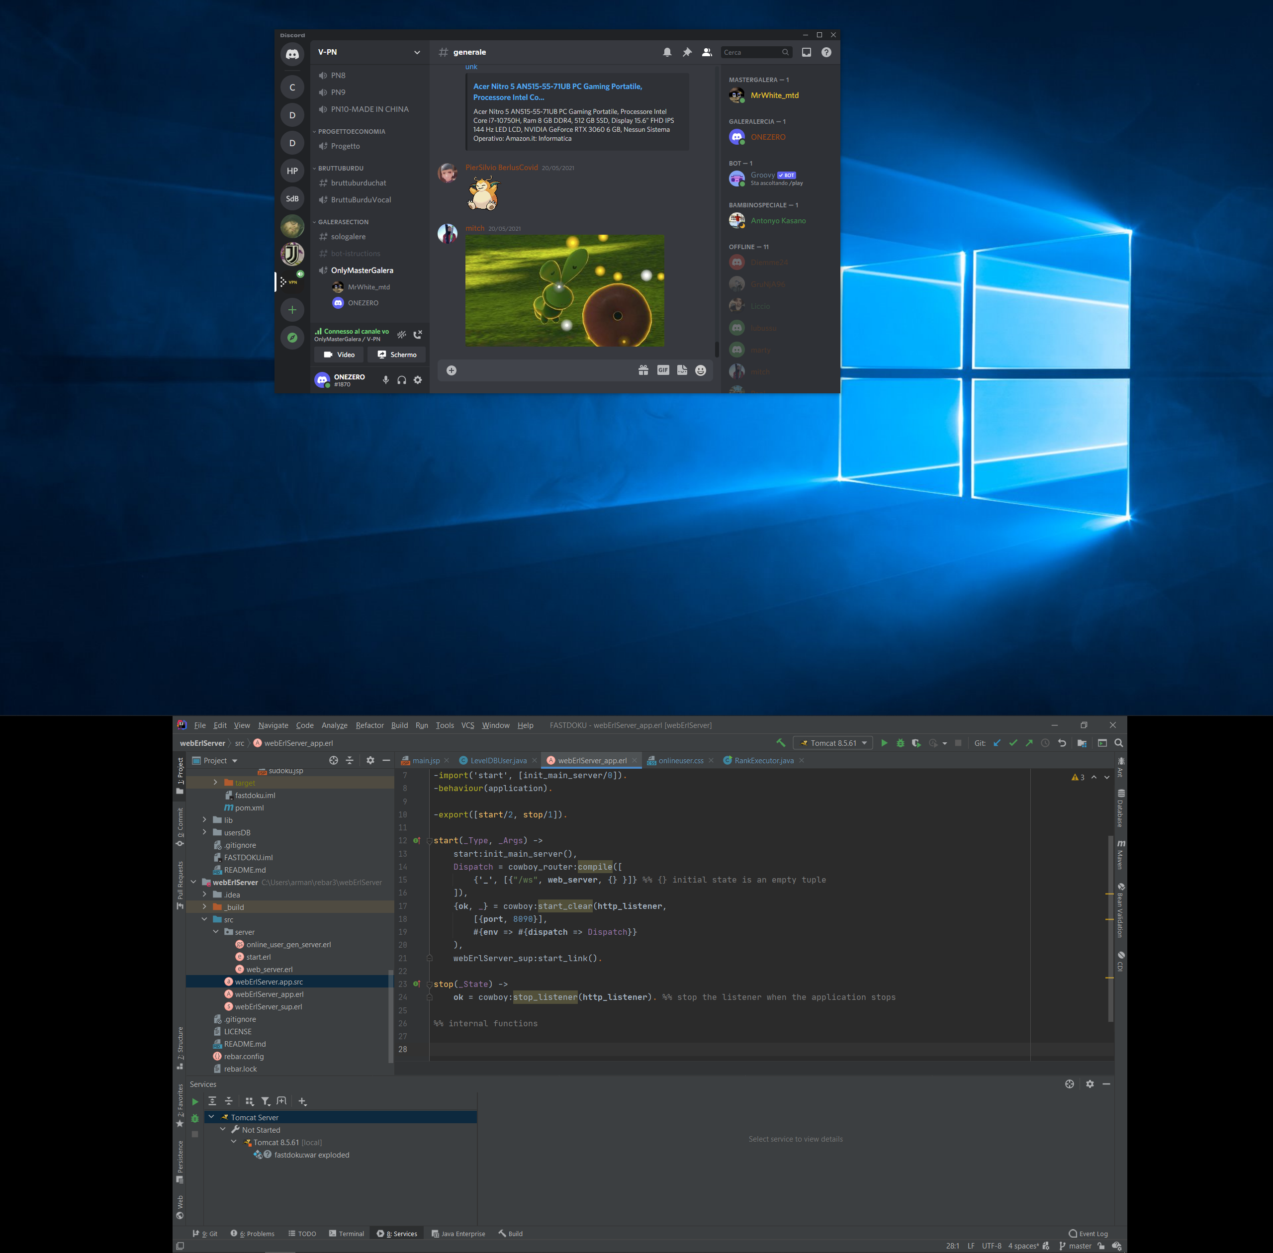

# Synchronization

When Tomcat receives the HTTP request from the client, it takes a thread from its thread pool, finds the Servlet object corresponding to the request and initializes it, and then calls the service() method. It should be noted that each Servlet object has only one instance object in the Tomcat container, which is the singleton mode. If multiple HTTP requests are issued for the same servlet, different thread will concurrently call the servlet's service() method.

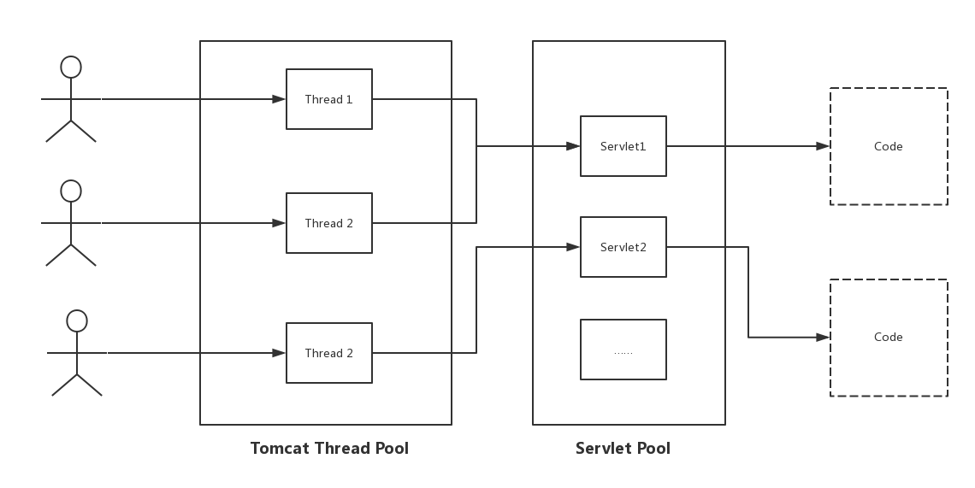

“By default, servlets are **not thread-safe**. The methods in a single servlet instance are usually executed numerous times simultaneously up to the available memory limit. Each execution occurs in a different thread, though **only one servlet copy exists** in the servlet engine.”

We come to the issue of concurrent access of LevelDB. As a database, it can be concurrently accessed by different thread. LevelDB doesn't allow more than a single instance of the database to be open, but multiple threads can operate with the same instance, as the [official documentation](https://github.com/google/leveldb/blob/master/doc/index.md#concurrency) asserts:

*“A database may only be opened by one process at a time. The leveldb implementation acquires a lock from the operating system to prevent misuse. Within a single process, the same leveldb::DB object* ***may be safely shared by multiple concurrent threads****. I.e., different threads may write into or fetch iterators or call Get on the same database* ***without any external synchronization*** *(the leveldb implementation will automatically do the required synchronization).“*

Following the Singleton design pattern, an instance of the class is created only the first time it is requested; from that point on, all calls to the getInstance() function will return the exact same instance. In this way we ensure that just a single instance of the LevelDBUser class is shared by the various Servlets that will perform some queries on the database.

This is a single class that provides controlled access to that resource, thus providing a **single point of entry** in the code for proper synchronization.

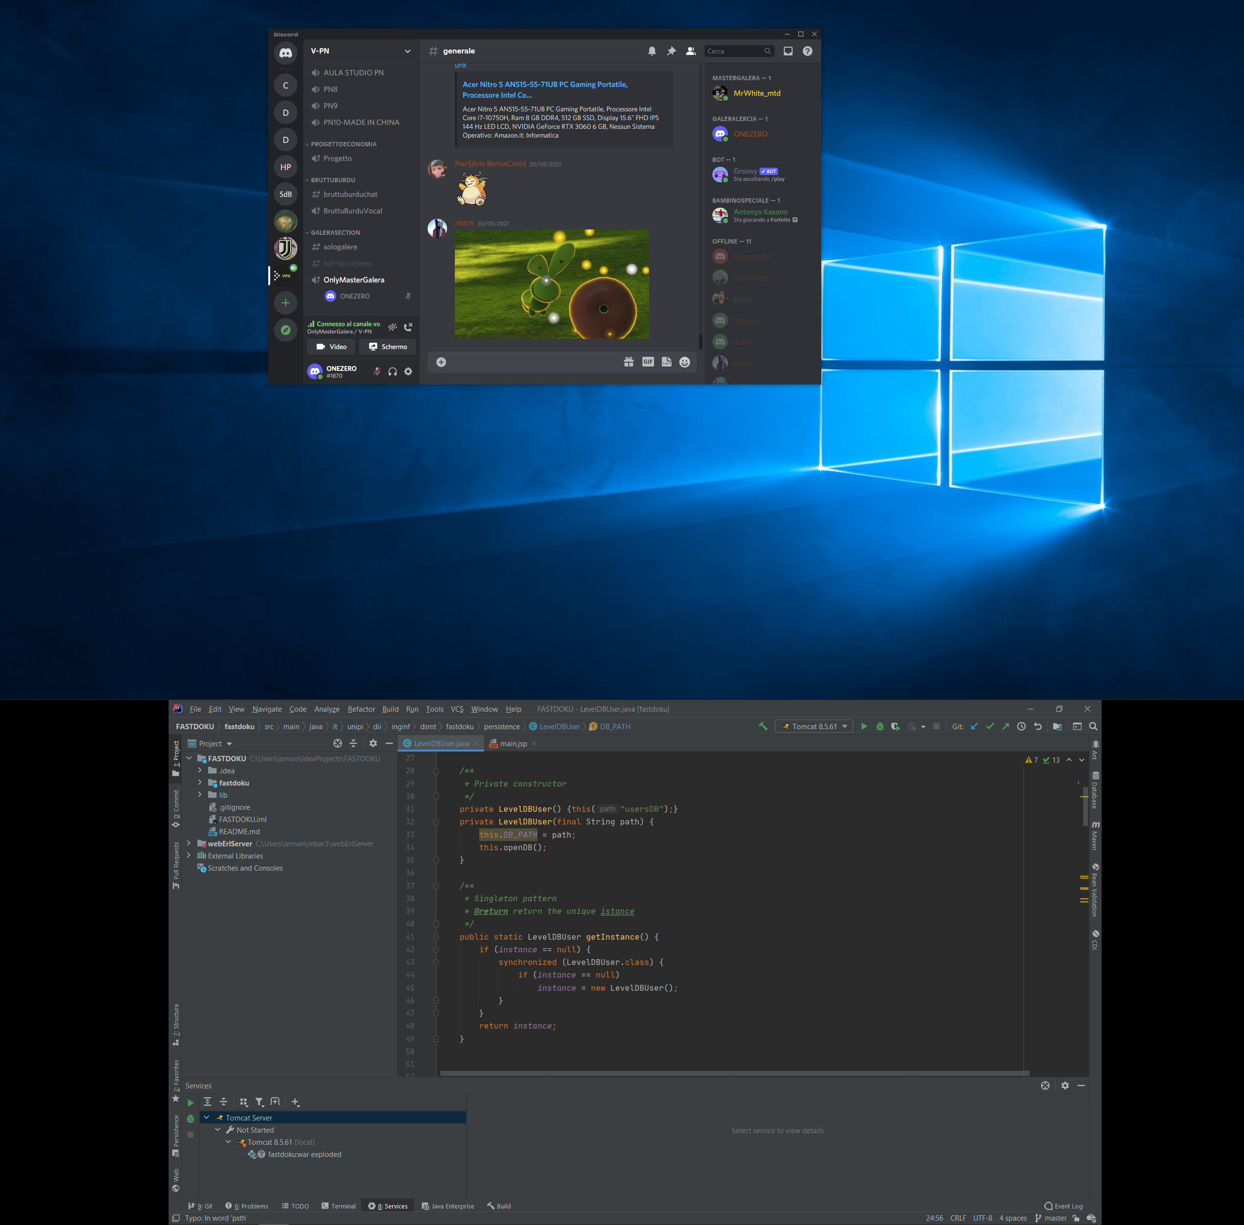

So, there was no need to take any other precaution: threads can call any method of the *LevelDBUser* class that query the database and it is LevelDB implementation that will take care of their synchronization.

For what concern the server in the Erlang environment it’s not necessary to add specific details. One of the strengths of this language is the ability to handle concurrency and distributed programming. The Erlang process required by the application do not share data and their only means of communication are messages, there is no need to handle synchronization issues.

# Communication

In this project the communication between the client (web browser) and the server is the core because allows the application to work.

The communication between client and server is implemented using a Web Socket Server, which has been developed using Cowboy as we have already discussed before. The client sends a request to the server and the server replies back; this communication channel is supported through a WebSocket protocol.

Moreover the processes themselves, which represent the users within the erlang environment, can communicate with each other exchanging some information without any explicit synchronization. An additional process, registered as a fastdoku_server, intercepts requests from new processes or processes that have just disconnected, in order to keep track of which processes are running.

The following figure represent how a match starts:

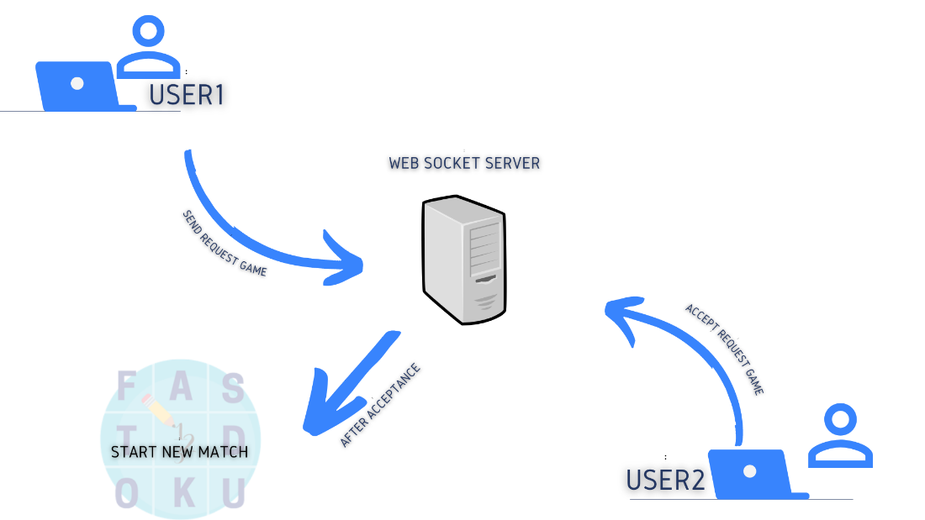

When a user sends a request to another one and he accepts the request, a new game start. The Erlang system terminates the previous processes and starts a new process for each user that are playing, now these two players are not available to receive requests. During the game there are no message between the players, until one of them wins or gives up. In both cases, each of the players is awarded points and then redirected to the main page. In the event that one of the two players is no longer available due to any problem (process crash) the game is ended and the challenger is redirected to the main page.

As we have already mention before, on the server side Tomcat Web Server communicate with the web browser and provides to users dynamic HTML contents thanks to Servlets and JSP pages technologies.

# Coordination

As we have already explained exchanging messages is the only way that allow the application to work. Receiving a message is an important event because it triggers an action.

The messages exchanged between the processes arrive asynchronously and are used to specify to the system how to go on and what will be the next operation to be carried out. They are necessary for coordination.

For these reasons a dedicated data structure for messages has been defined to support this mechanism and the chosen format is the json one. Several types of messages have been defined which differ based on the content of the type field.

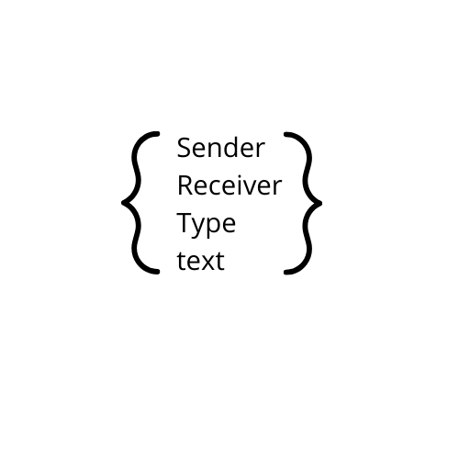

The type field define the behavior of the system while the other fields contain information necessary to forward a message to a specific player or remember who the challenger is.

Some types of messages are listed here:

*register_me*: crucial action because it involves the registration of a process within the erlang environment, moreover add the users among the online user available to receive requests. The list of users currently online is sent as response. If the process is already registered it means that the user is already online with another web client, so the access is denied.

*add_online*: this operation adds the user in the gen_server that handle all the users online and ready to play. if the process is not already registered the operation is denied.

send_request: when a user has chosen the difficulty, he can send this type of message which will be forwarded to his opponent.

*play_start*: when a user accepts a challenge a message is sent to the opponent and the game immediately starts.

*register_opponent*: the user’s process changes his state and keep the username of the opponent.

refuse_request: a request can be refused, so the sender must be informed.

*win*: a user has successfully completed the puzzle; this message is forwarded to the challenger to inform him that the game is over. Both processes are terminated, each player is awarded their respective points and redirected to the main page.

*surrender*: one of the users has decided to surrender the game, so the other one have to be informed.

There are two other situations that cause a message sending, in both cases it occurs when the connection with the WebSocket is lost. Two callbacks have been defined to handle these events exploiting the *terminate* function provided by the framework.

When a user disconnects from the game because he has clicked the 'logout' button or because he has closed the web browser, all other users are informed in order to avoid sending requests to an unavailable user, through a message ‘*remove_user*’.

A critical event could occur during a match if one of the two users suddenly disconnects. As mentioned above, no message exchange takes place during the game so, a user would discover that his opponent has left the game just after solving the puzzle. This problem is solved by sending a *‘opponent_disconnected*’ message to the user who is still playing, redirecting him to the main page.

# User Manual

The manual for using the application is described below.

The first page of the application is the login page. A registered user can insert ***Username*** e ***Password*** and click the button ***login***.

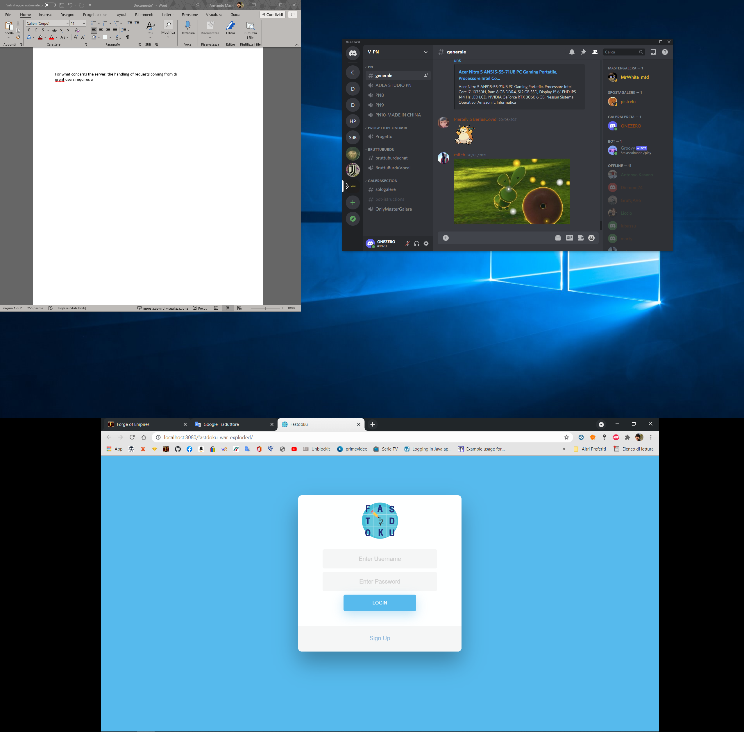

A non-registered user needs to click the button ***Sign Up*** and another page will appear where he will choose a ***Username*** and a ***Password;*** some constraints mut be resected: the username can contain numbers and characters, but not special characters, while the password must be long more than 6 characters. After completing the procedure ***Sign Up,*** theUser automatically **login.**

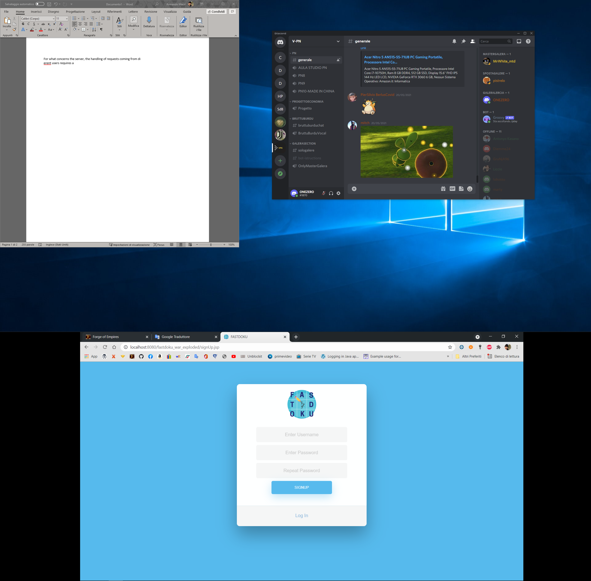

After the login, the application show the User’s homepage. At the top are displayed the players' information such as his/her username and points. Moreover two button may be clicked: the delete button allow the user to delete his profile and all his/her information, while log out means that the user log out from the application.

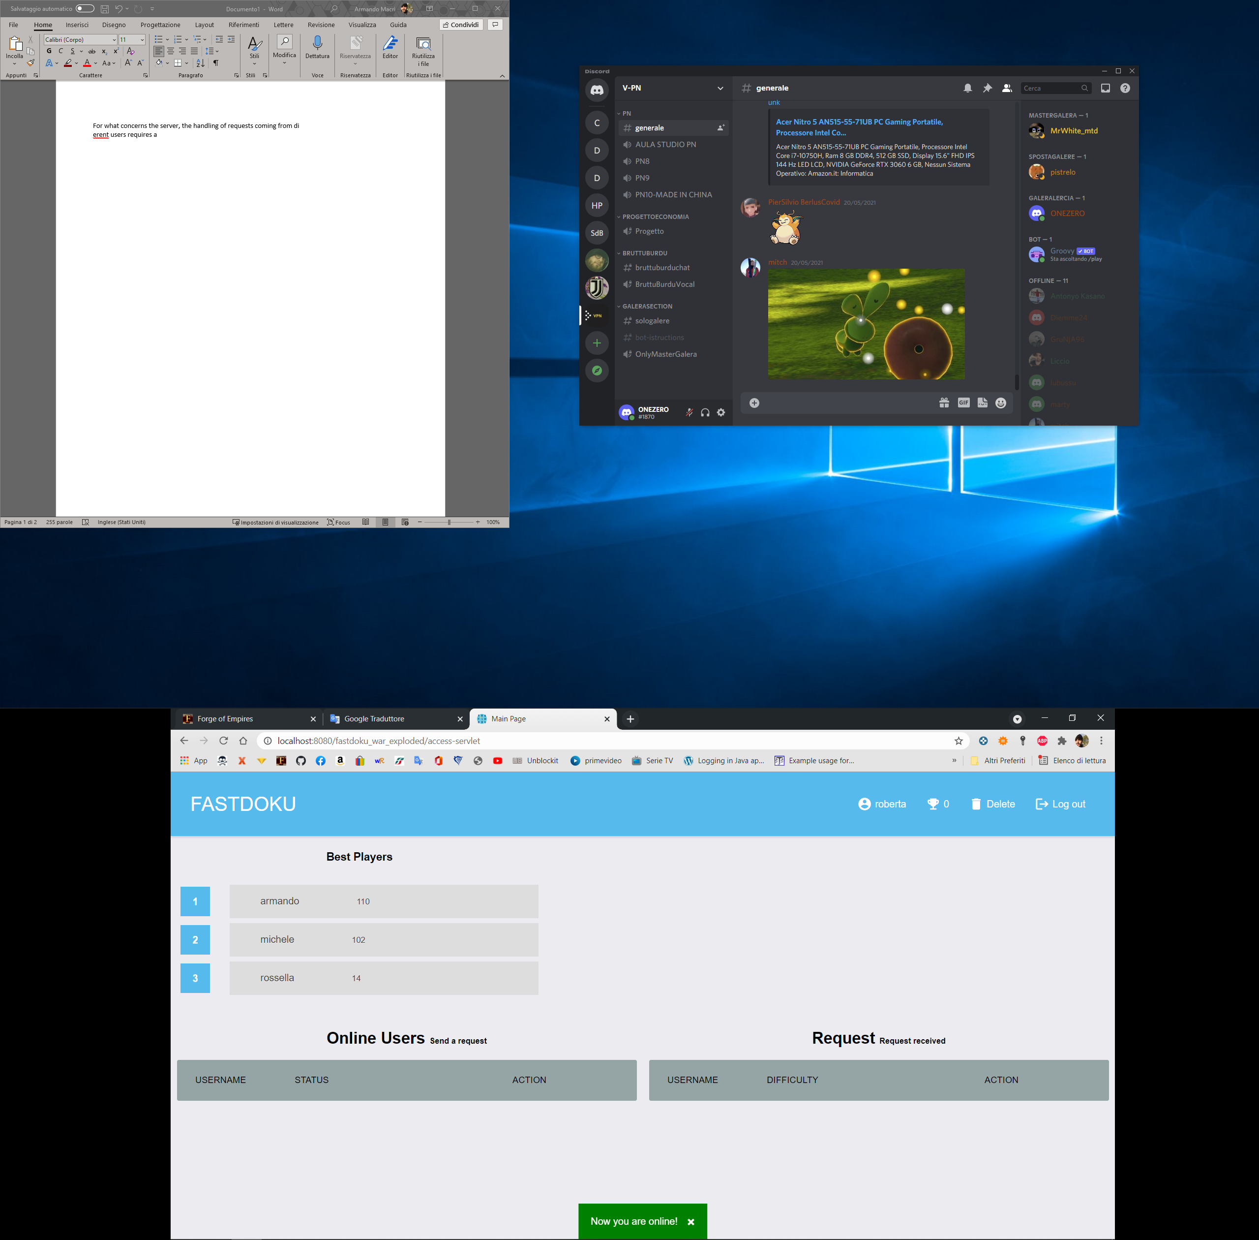

In the middle is present a ranking table where the strongest players are listed.

On the bottom two different table are displayed: respectively on the left the online players table and on the right the requests received table, in both tables a username and the level of difficult and shown and an action could be performed.

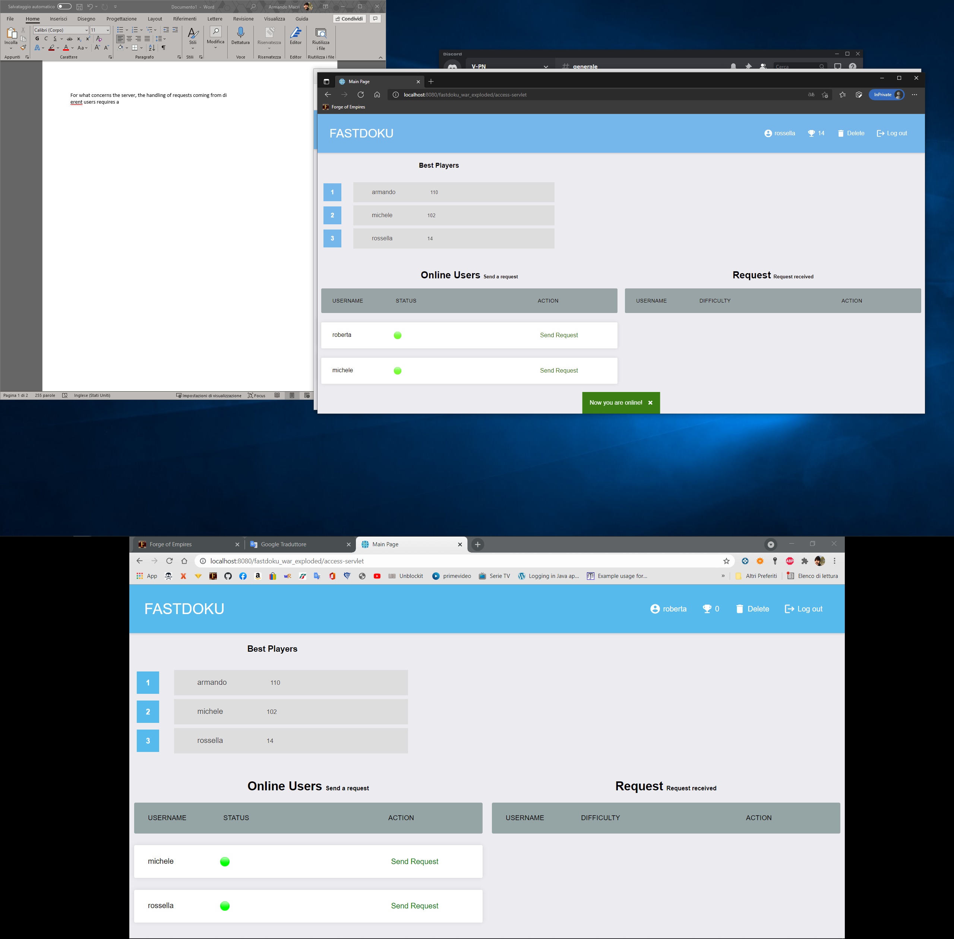

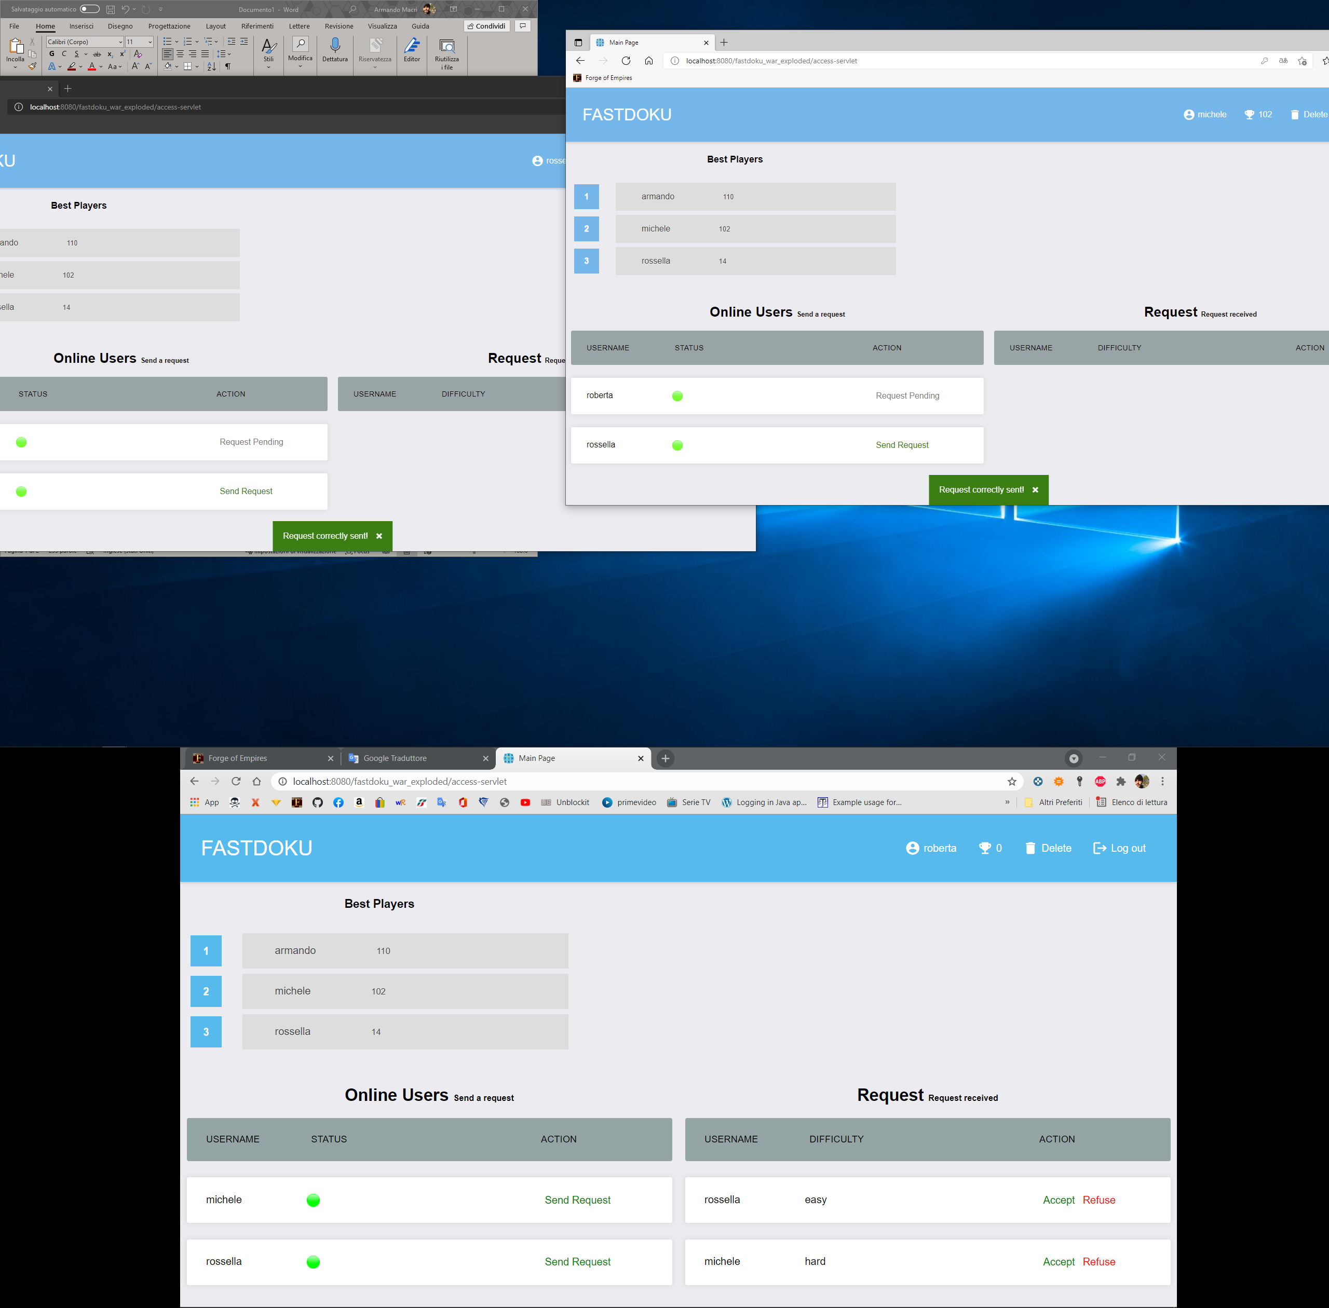

When a user become available to play (logged in the application) a new row is added in the online users table. Online users can be challenged by sending a request through the button “Send Request”.

When a user receive new request a new row is added in the request received table. In this case the user has two possibility: decline the request with the button “Refuse” or accept it with the button “Accept”.

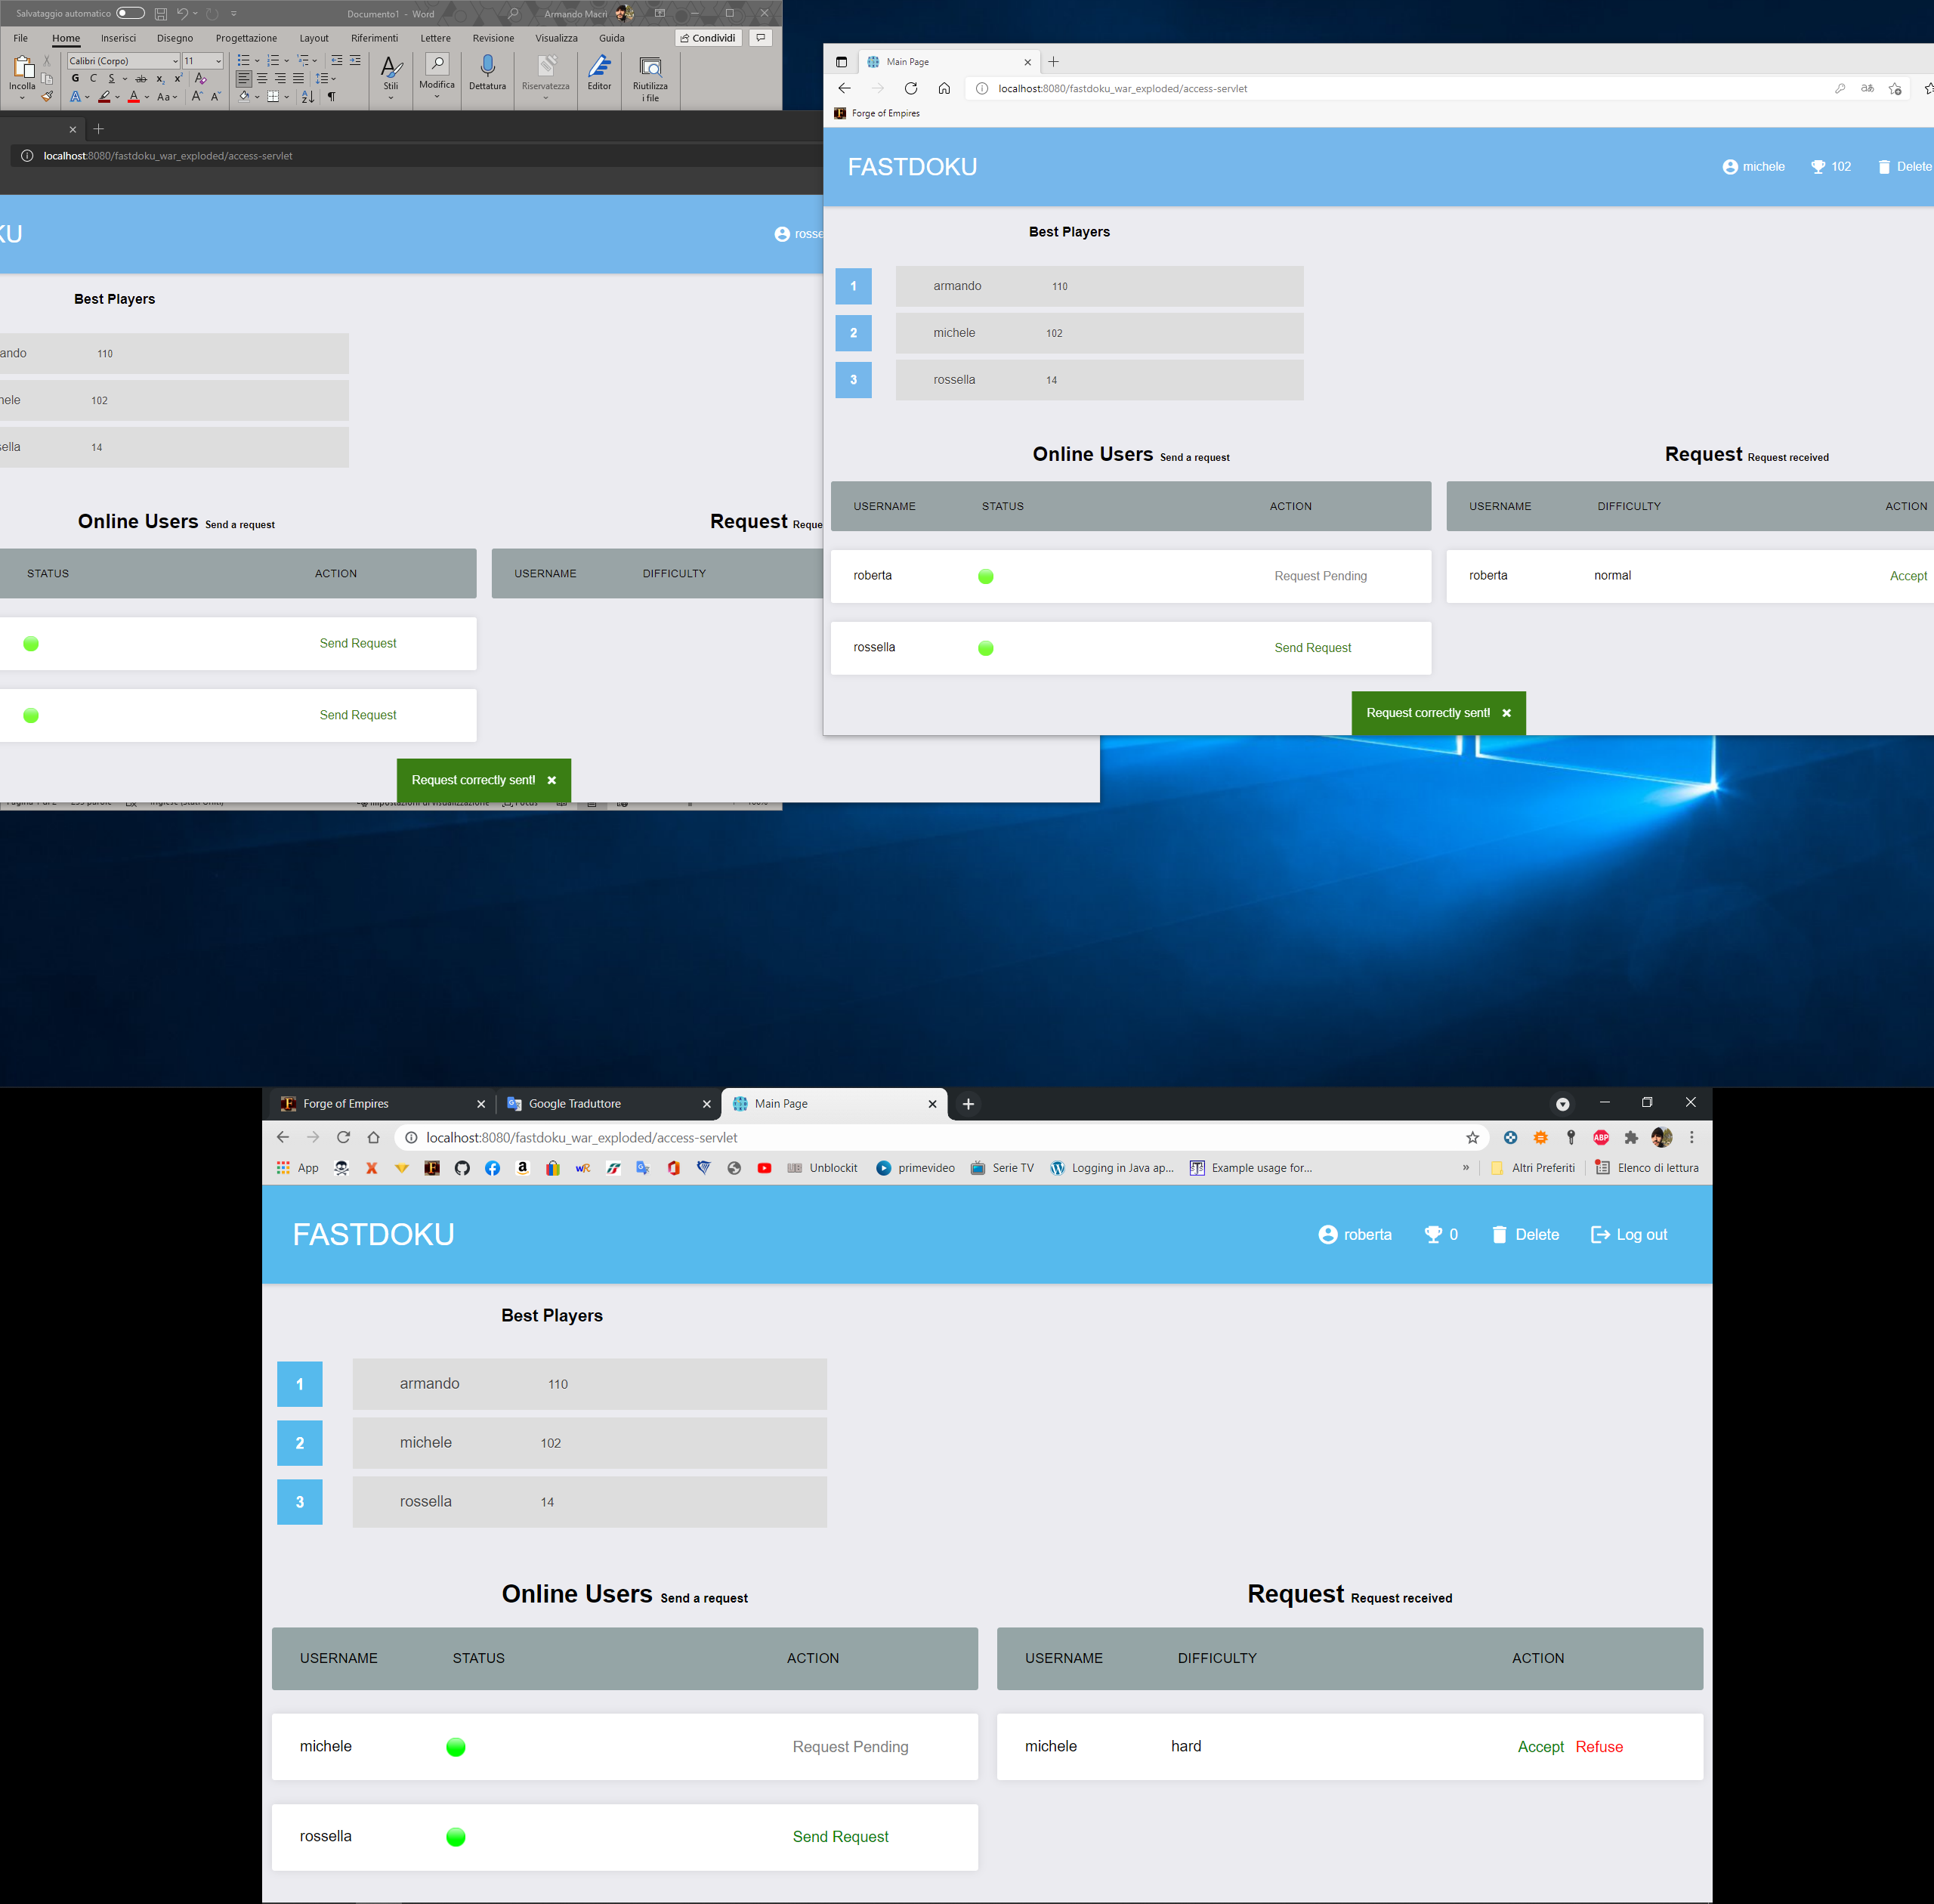

When a request is sent, the “Send Request” button is disabled. You cannot send more than one request to the same user.

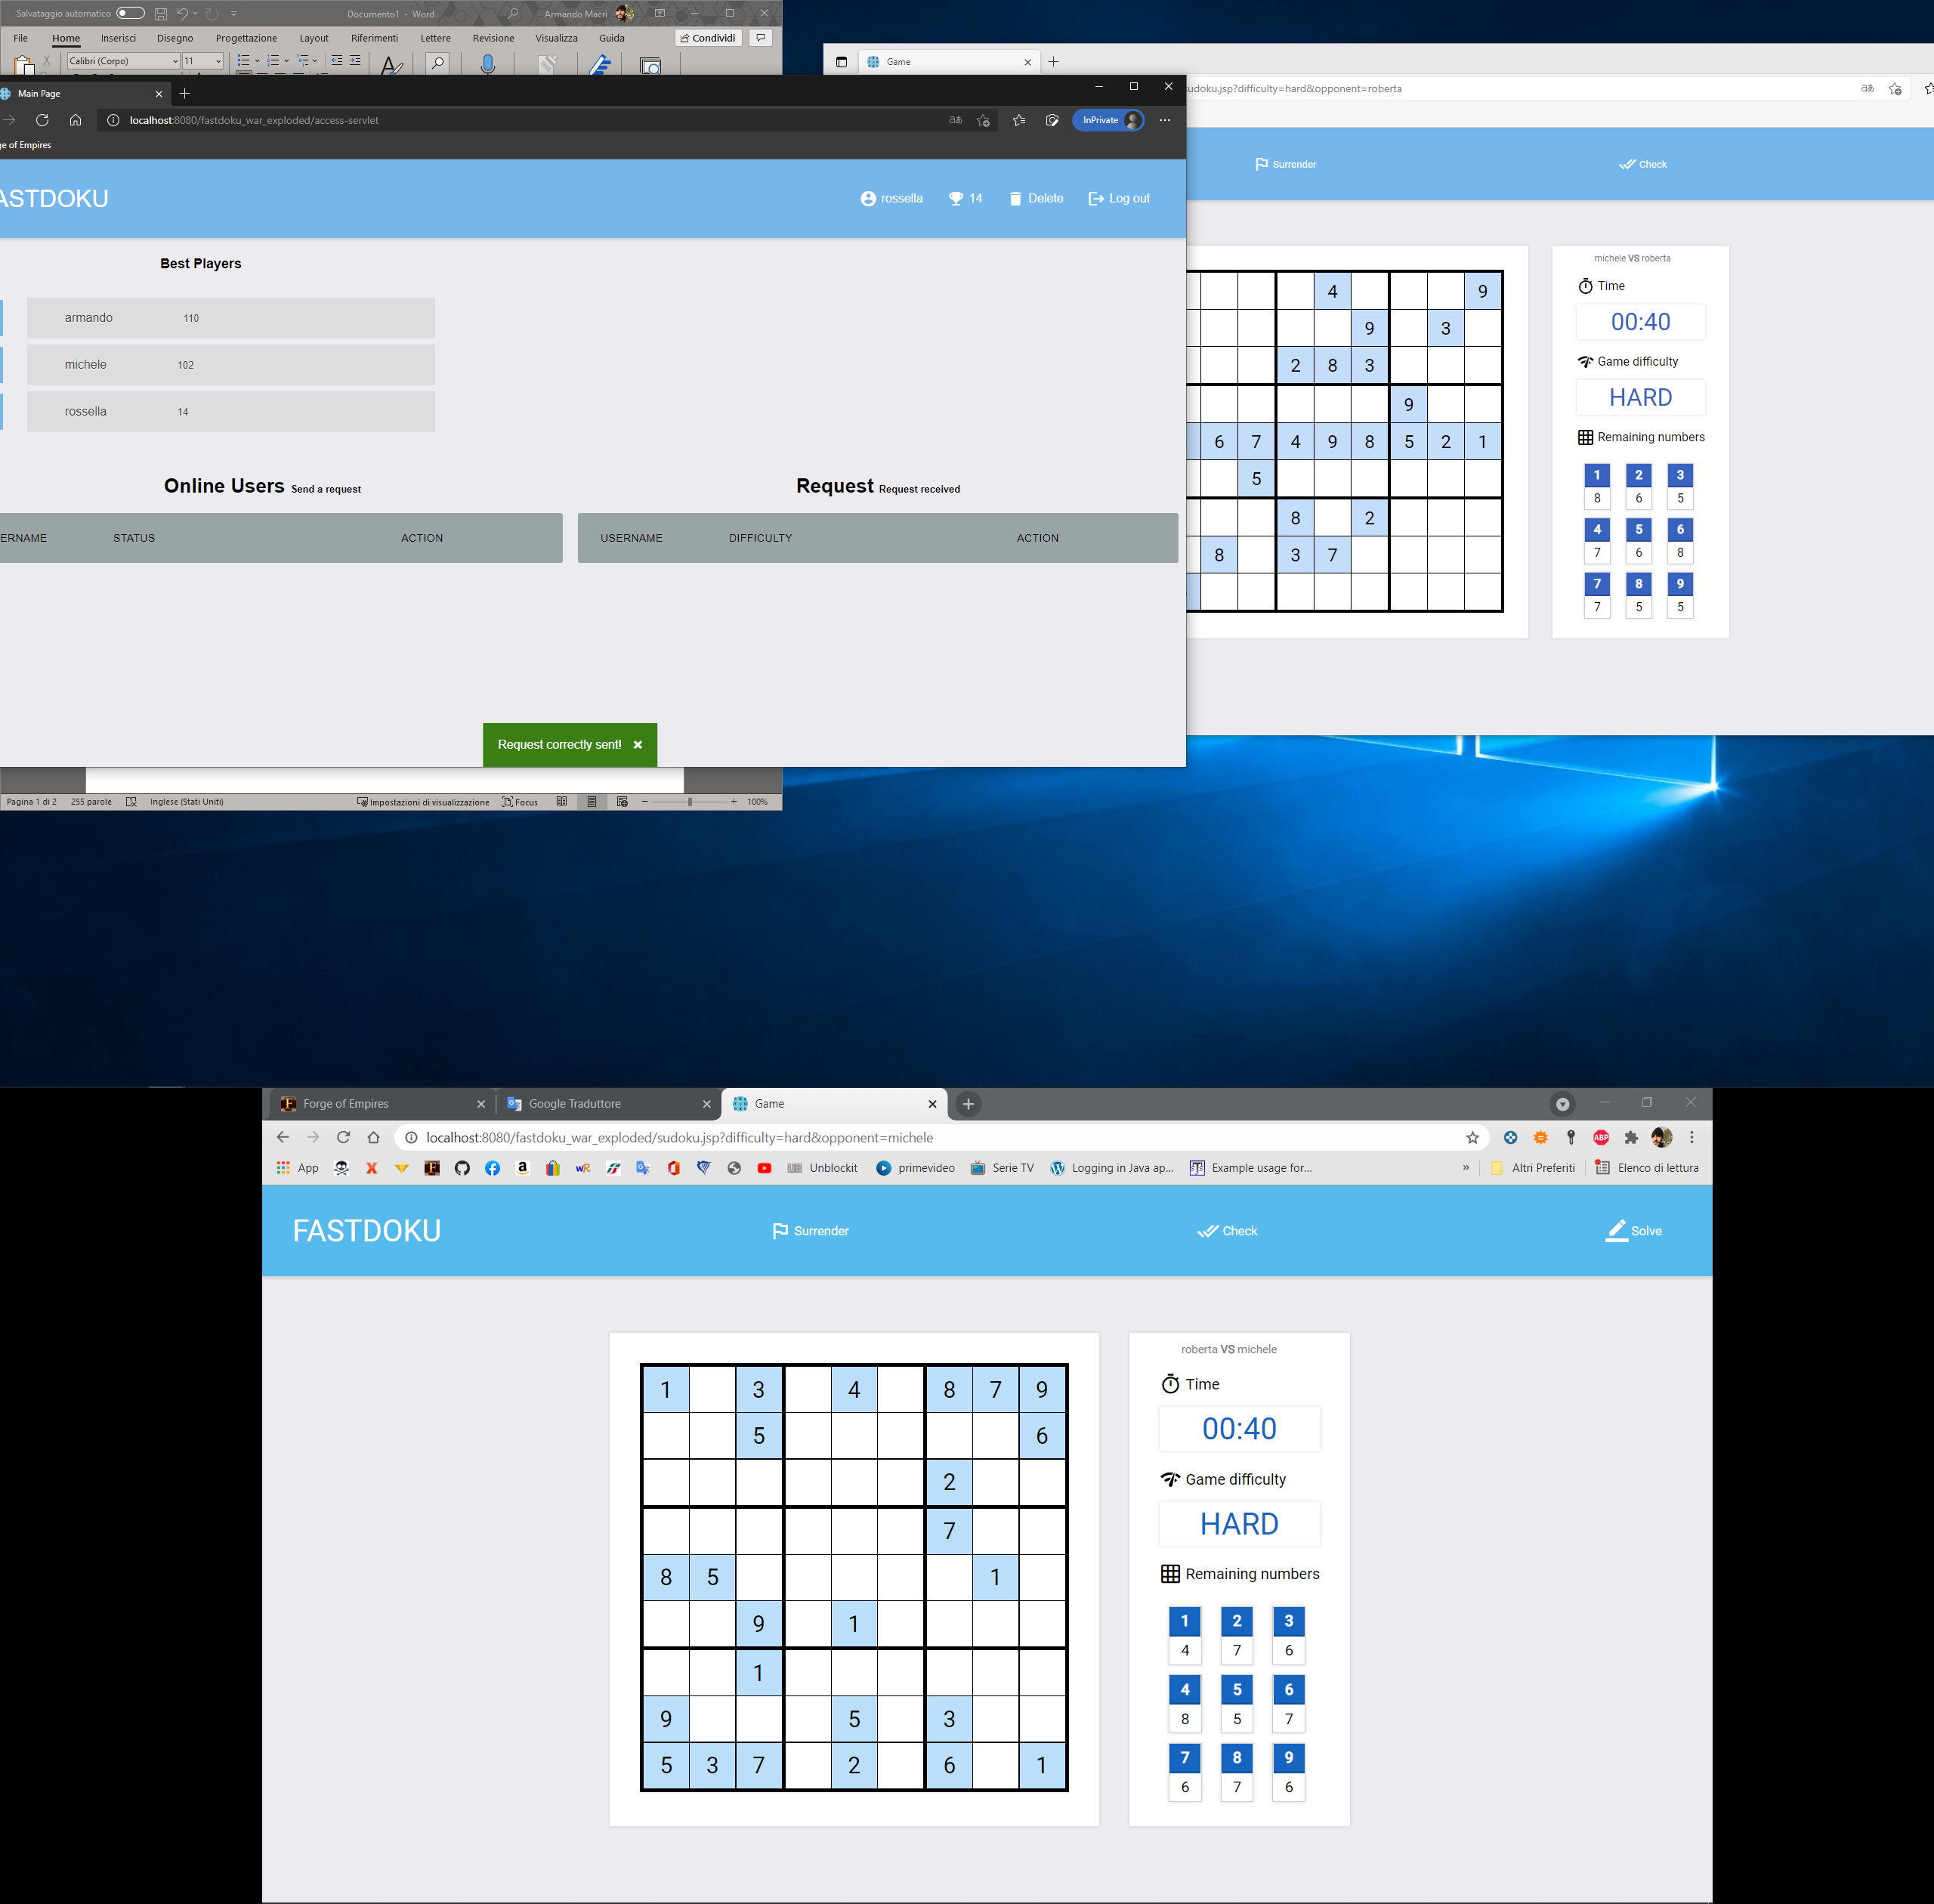

When a request is accepted from an user, the game starts immediately and both the users are redirect to a new page.

On the top there are two main button: the “Surrender” button an user can click when he/she wants to leave the game voluntary or the “Check” button that an user can click to check it his/her solution is correct.

In the middle we can see a grid with white cells that the user can modify and write numbers while the light-blue cells are fixed. Moreover is present a field for the chronometer, which starts as soon as the puzzle is shown, the game difficulty field and finally a table of “remaining numbers” that show how many more times each number must be typed into a cell.

Of course the cells are editable: just select the box where you want to enter the number and once entered, the correspondent number on the right table will decrease.

When the remaining numbers have run out, you can “***check*** the puzzle”.

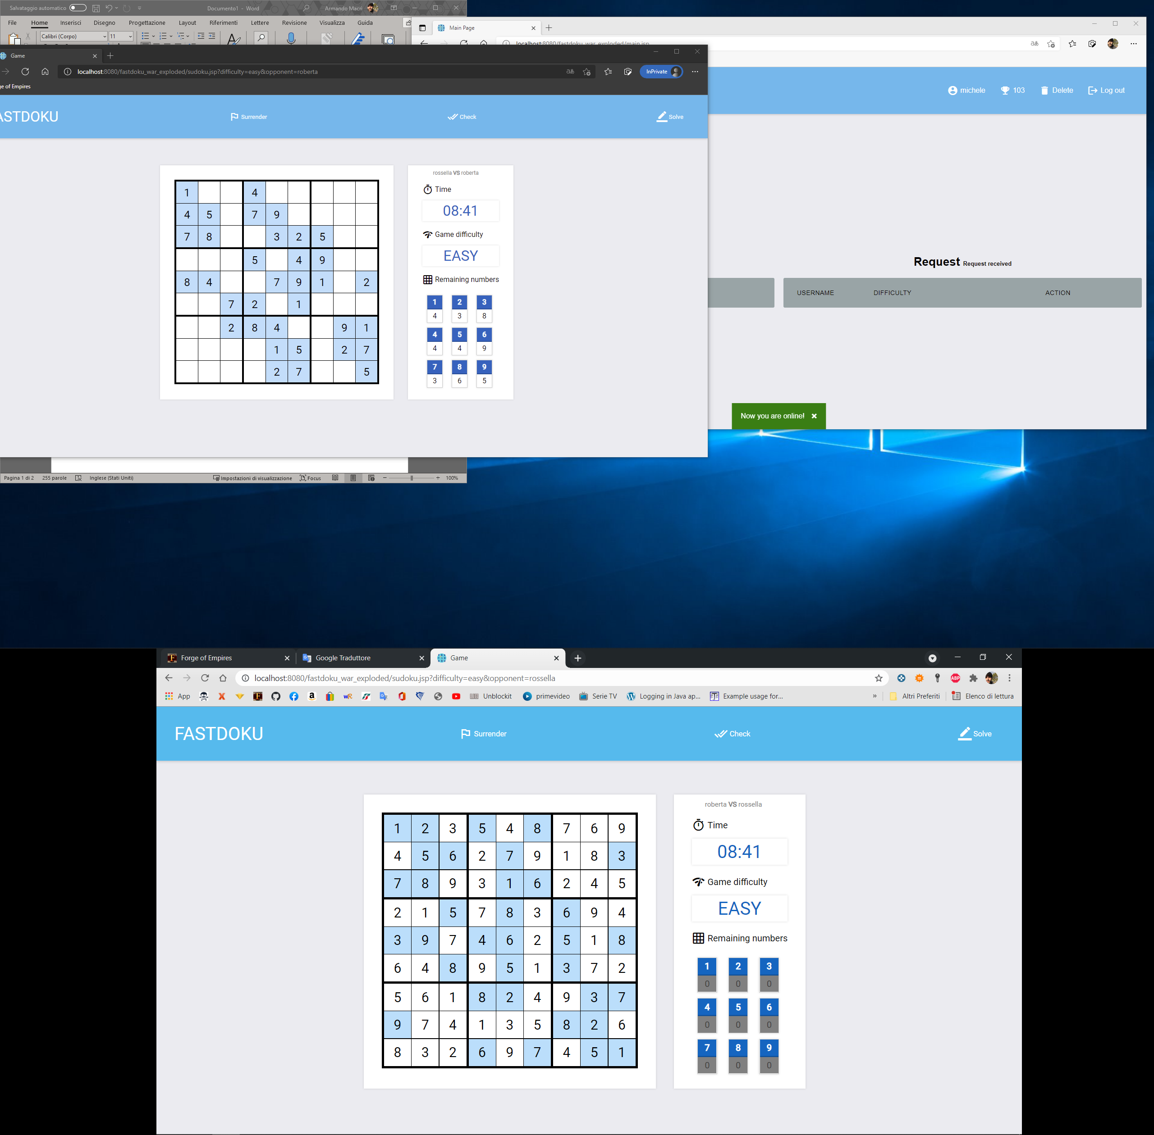

If the puzzle is correct, the match ends and both the User earn some points calculated based on the level of difficulty and the time taken to finish the sudoku.

These are the messages shown to the players.

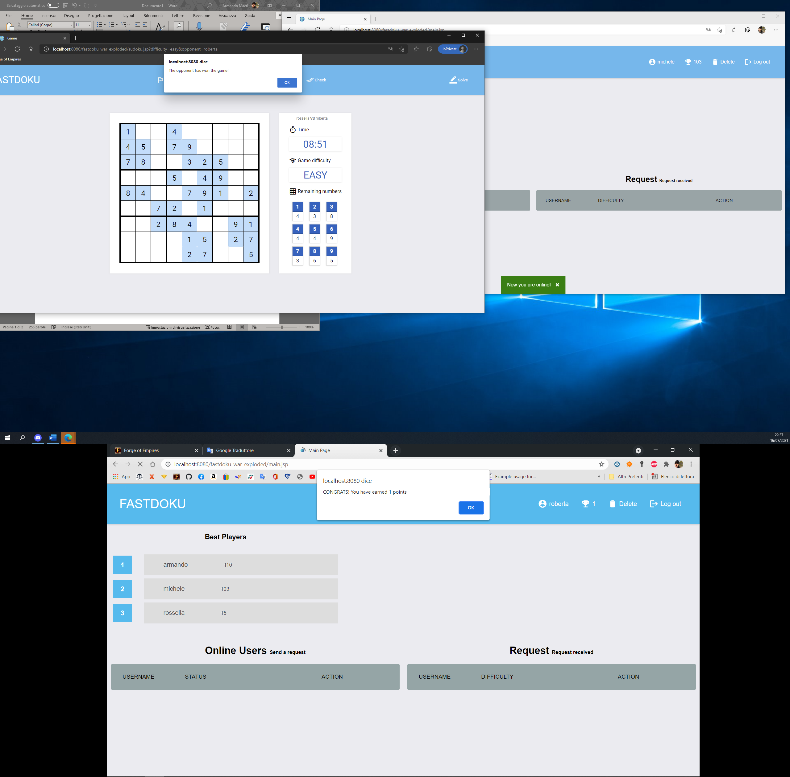

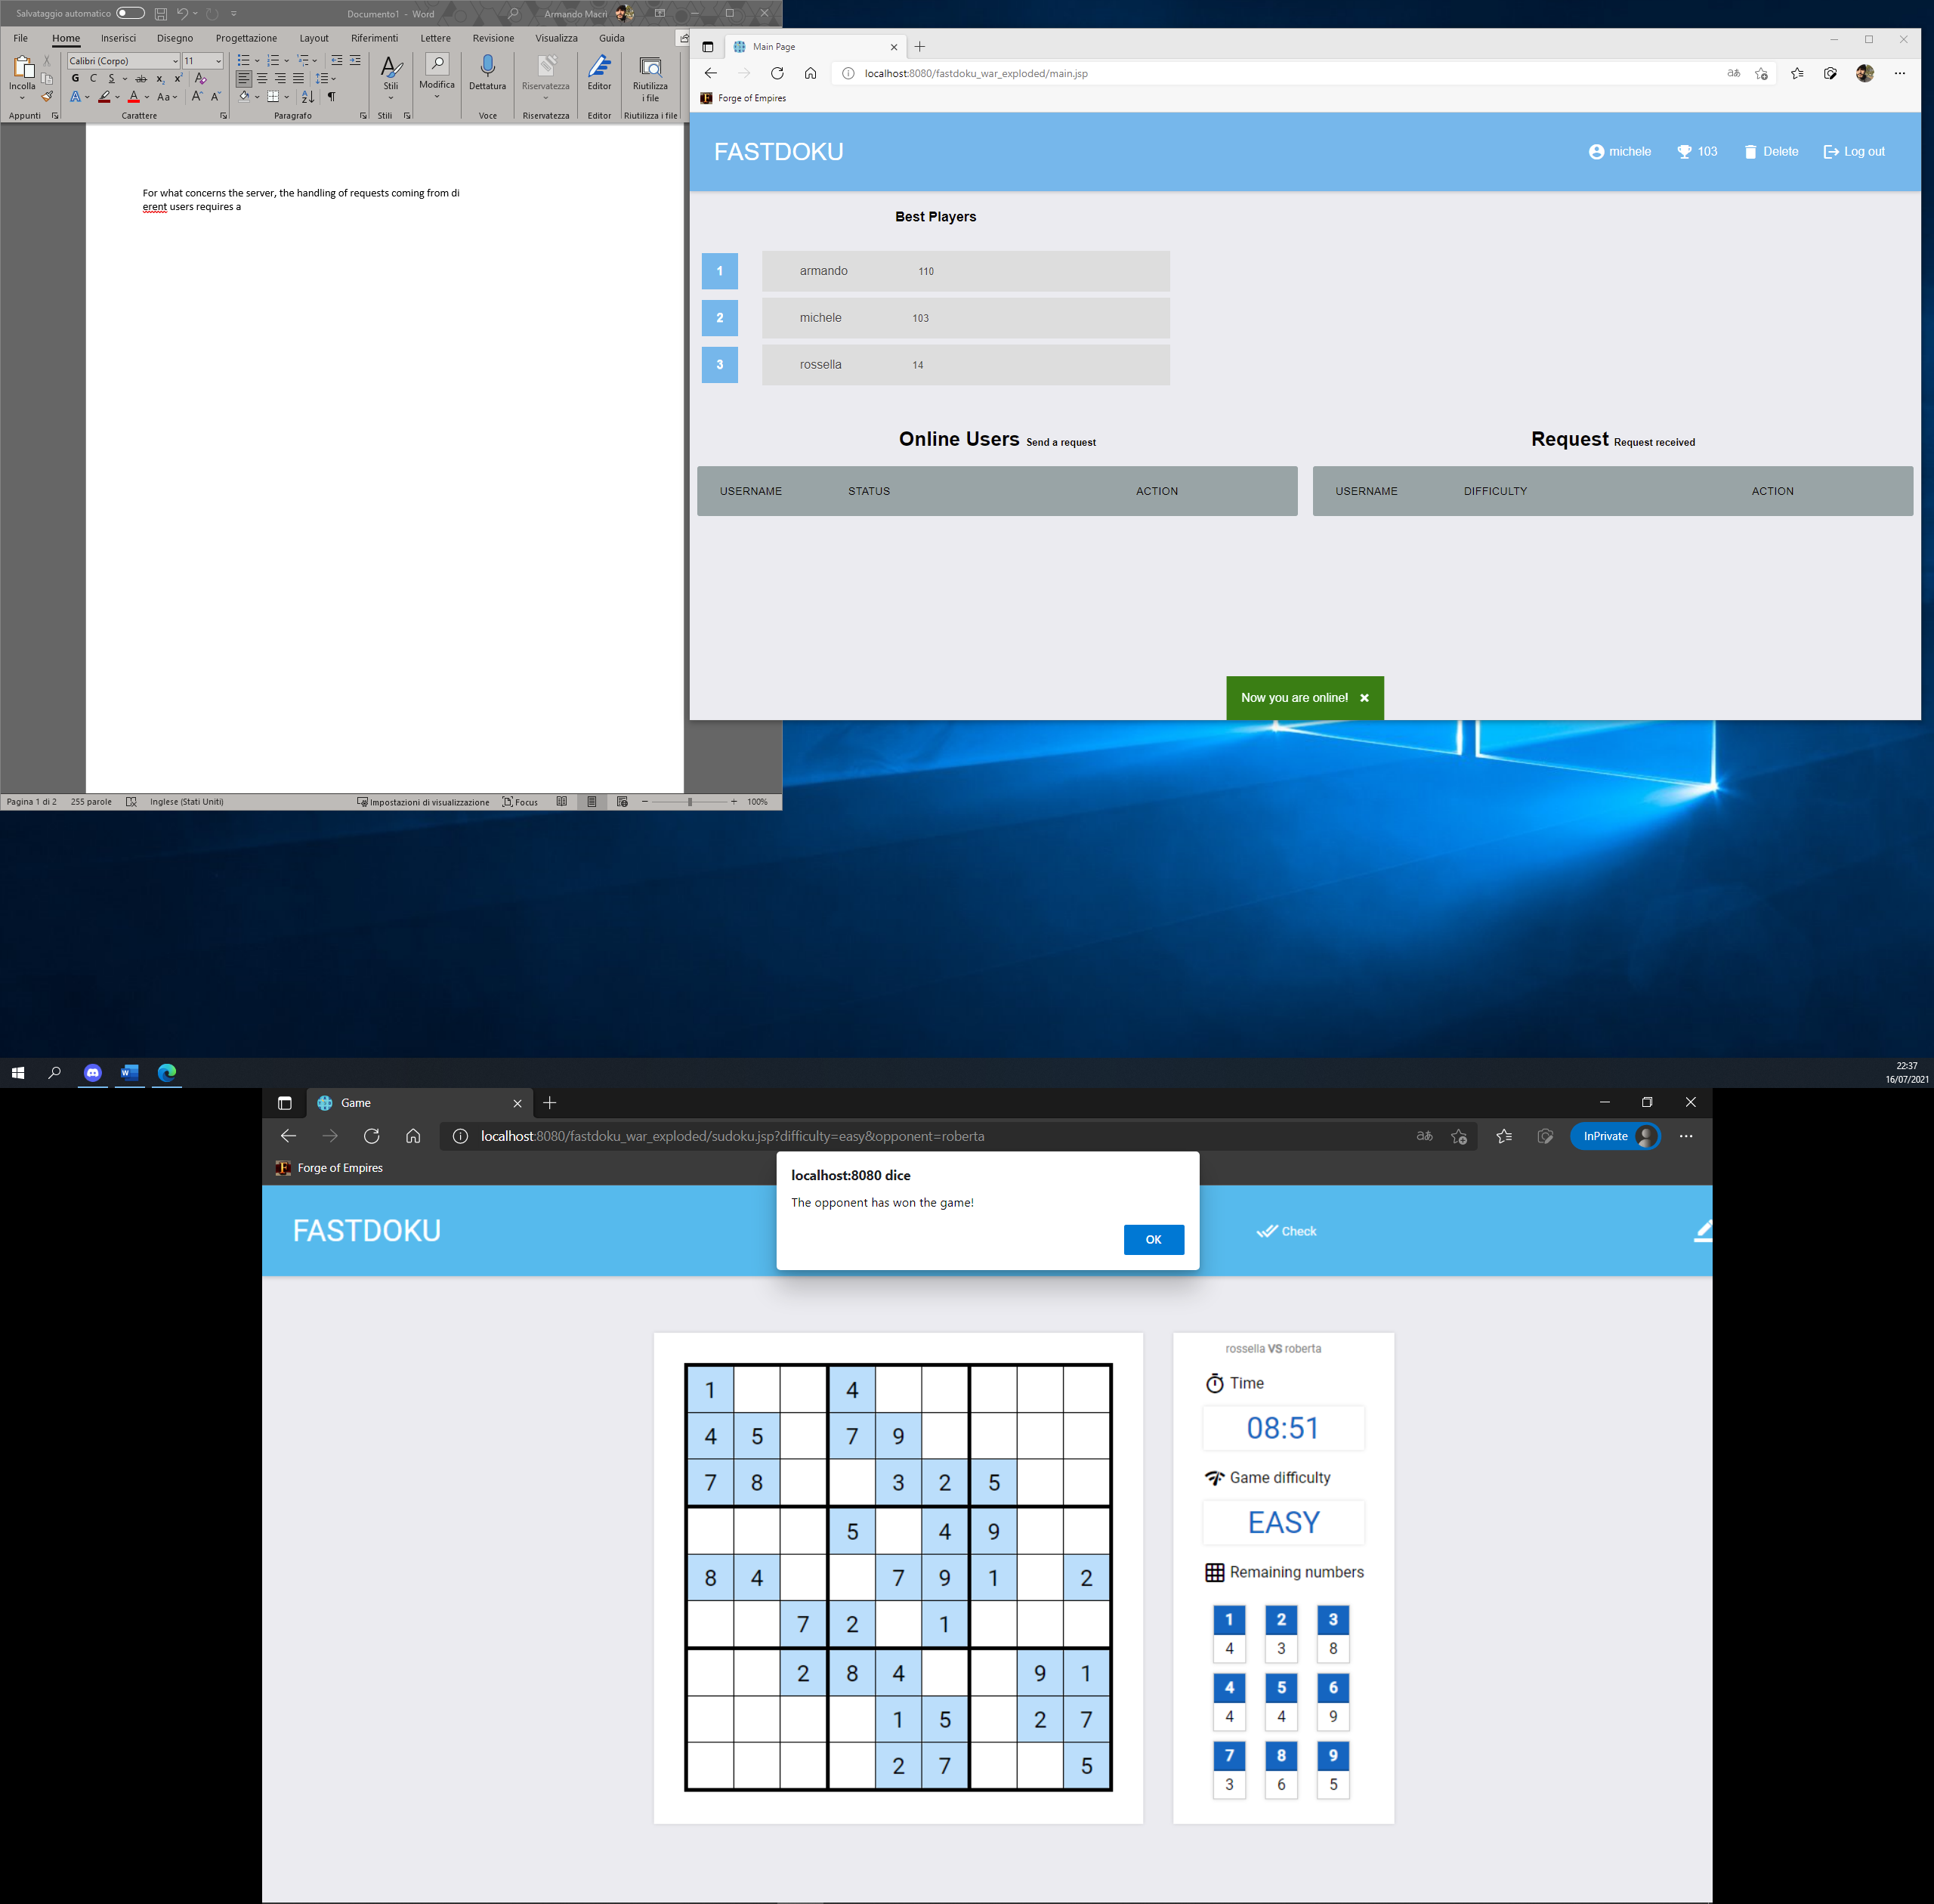

When a user out the game page, the game ends and a window appears to the opponent in order to inform him/her of the reason why the game ends. In one case the opponent has clicked on the surrender button, in the other case the opponent has los the connection with the WebSocket.

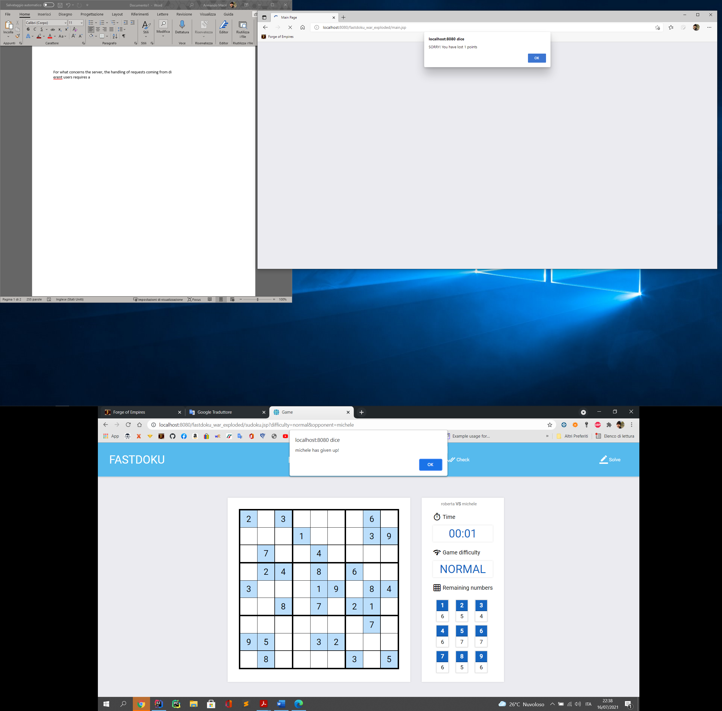

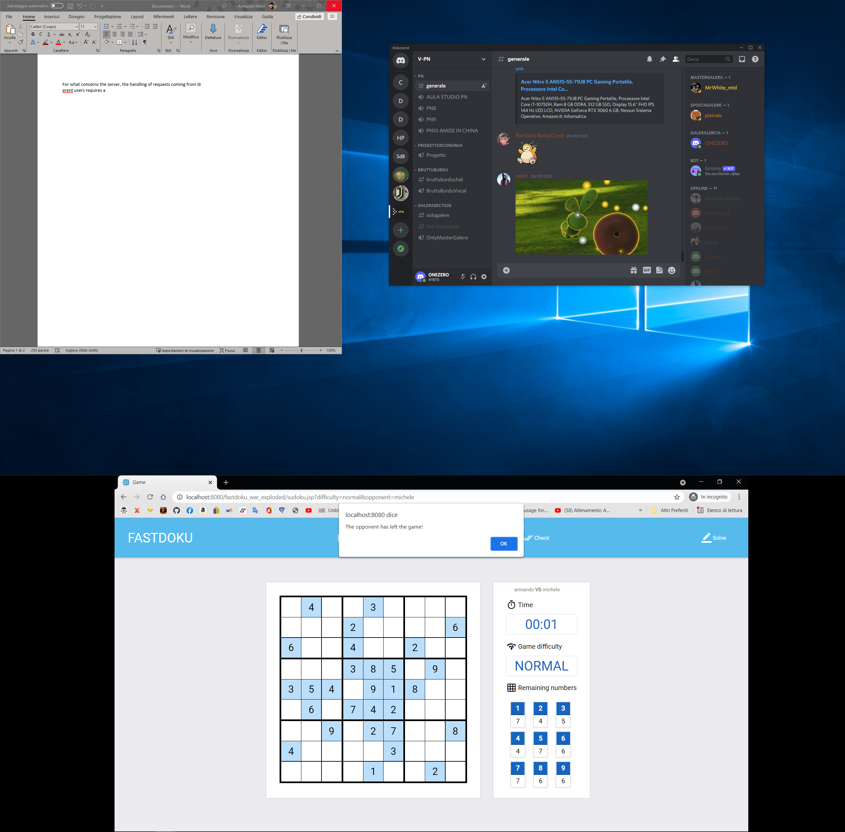

If the application server is not available and the user attempts to login, he/she is redirect to the login page, and an error message is shown.

